~
MEETING |  |  |  |  |  |  |  | 
Minutes of meeting n° 7 |  |  |  | 7 |  |  | 03/12/2025
Location : Penta Hotel City Center - Brussels |  |  |  |  |  |  | 03/12/2025
Distribution on 06/12/2025
Attendance | Present | Excused | Invited |  | Diffusion |  |  |  | Present | Excused | Invited | Diffusion
MO – Penta Hotel City Centre  Menno de Richemont |  | X | X |  | X | Contractor - NTSA  Thibault Fayd  Site supervisor (APO) |  |  | X | X | X  X | X  X
MOD – Immo-Pro (IP)  Olivier Fournier (OFO)  Leonardo Stefani (LST) – 0474/015.062 | X | X | X  X |  | X  X | Contractor – Pro4Finish (P4F)  Cedric Van der Burght |  |  | X |  | X | X
BET TS – TsfPlus  Grégoire Sillen |  | X | X |  | X | Contractor – The Belgian (TB)  Johan Boets  Armend (Subcontractor - Artelelectro) |  |  |  | X  X | X  X | X  X
ARCH – De Bouwerij  Paul De Mulder  Iskra Bilic  Sofie | X  X  X |  | X  X  X |  | X  X  X | HSE coordinator – Whiteforge  Abdel Saifi |  |  |  | X | X | X

Next meeting :
Change of weekly execution meetings on Wednesdays at 11:00!
10/12/2025 at 11 :00 – On site Chau. de Charleroi nr. 38, 1060 Brussels

C General

C1 Approval of the previous minutes of meeting

Néant

C2 Information exchange

From whom | Status | Content | Due date
IP | To send | Photo report of the staircase | 18/10
P4F | To send | P4F still needs to communicate the VAT number of the company. | 27/11
P4F | To send | Updated technical data sheets for fire sealant and pictures of the fire seals already executed. | 27/11
ARCH | To send | Photo report of level +6 ensuing the site visit on 03/12 | 10/12
P4F | Sent | Unit price for the new inspection hatches needed in the false ceiling (groundfloor and level +8) | 01/12

C3 Planning

Planning item
Level +6 will be out of service on the 10th of November 2025 at 14:00
- 12/11: Floor protection
- 13/11: Start of drillings and noise
- 27/11: Painting and fire sealings
- 04/12: 6th level will be back into service
As of Monday 01/12, the fire detection of the hotel will be renewed
Floors out of service for fire detection PLANNING CONFIRMED
- +6, -2, -1 et REZ : 01/12 7 am – 05/12 (finalise lvl +6 by thursday 04/12 – Confirmed)
- +5, +4, +3 and +2 : 08/12 7am – 12/12
- +1, +7 et +8: 15/12 7am – 19/12
Level +5
- 04/12: Start of the floor protection
- 04/12: Start of the sprinkler works

D Discussed subjects

N° | Title | Subject – General | For whom | Due
04.01. | Maintenance works | - As the hotel is still in activity, maintenance works are still being carried out. The following works are currently not included in the scope of this project and are only part of the daily maintenance of the hotel:  - Regularisation of the fire sealings of existing and openings |  | Pro Memorie
04.02. | Check in at work | - The check in at work QR-code has been displayed at the entrance and at the lobby.  - All companies carrying out works on site related to the scope of works of the project are required to register all their workers via this QR-code or online via the project number.  - An excerpt of the registrations will be sent by all contractors to IP on a regular basis. |  | Pro Memorie
07.01 | Planning | - New planning to be issued with additional details concerning the fire detection works and finishing works. | MOD | 10/12

N° | Title | Subject – Sprinklers | For whom |  | Due
01.03. | Execution strategy | - Execution floor per floor starting from +7 working our way down to +1  - A detailed schedule for the closure of each level and the noise periods (drilling) needs to be transmitted to MO.  - The contractor will be on site during weekdays from 7:00 to 15:30.  - Noise will be kept at a minimum from 7:00 to 9:00. |  |  | Pro Memorie
01.04. | Noise and drilling | - MO communicates that daily drilling is not an option for the hotel:  - Heavy drilling will be executed per floor over a period of 3 to 5 days. The exact dates will be communicated in advance to MO (see overall schedule).  - Outside of the heavy drilling periods the noise needs to be kept at a minimum. Occasional short drilling is permitted but will be executed between 11:00 and 15:00. Outside those hours no drilling is permitted. |  |  | Pro Memorie
01.05. | Protection | - NTSA will contact its subcontractor and organize a meeting on site to provide a quote and time delays for the protection of the floor and furniture for each floor.  Meeting 14/10:  - The protection of the floor +7 will happen on the 18th of October. Guests will still be leaving in the morning; the contractor will make sure to check with reception if the rooms are free to be protected. |  | NTSA | Done
03.01. | Drilling | - The drilling works will be carried out with a dry method. An aspirator will be used while drilling to prevent the dispersion of dust as much as possible. |  |  | Pro memorie
03.02. | HSE coordinator | - The company “Whiteforge” was appointed as HSE coordinator and will execute a weekly round on site. |  |  | Pro memorie
04.03 | Drillings | MO has requested the main drillings to be planned on Friday 14th of November as an important event is planned on Thursday.  No comment from NTSA, those drillings will be planned as requested. |  |  | Pro memorie
04.04 | Assembly of sprinkler network | For the following levels, NTSA confirmed that they can execute the pipes from the corridor to the rooms first (instead of finishing every room one by one). This will permit the finishing works to start earlier. |  |  | Pro memorie
06.01 | ANPI | A visit with ANPI is scheduled on the 28/12 to review the current layout and remaining remarks. |  |  | Pro memorie

N° | Title | Subject – Finishings/Architecture | For whom |  | Due
02.03. | Level +8 conference rooms | - MO has confirmed that the project of changing the level +8 (currently conference rooms) into additional sleeping rooms, is no longer being considered. The current works will have to take the existing layout into account. |  |  | Pro Memorie
03.03. | Emergency lights | - Immo-Pro will contact “The Belgian”, contractor in charge of the maintenance of the fire safety equipment, to provide a quote for the relocation of the emergency lights and sirens that are in the way of the future sprinkler tubes. |  | Immo-Pro | 18/10
04.05 | Technical data sheets | Pro4Finish has introduced technical data sheets, for approval by ARCH. |  | ARCH | 10/10
04.06 | Painting works level +7 | The painting works on level +7 will be carried out partly after the release of the level.  Pro4Finish will coordinate with the lobby to carry the necessary works in the rooms.  Meeting 27/11  - The finalisation of the works on level +7 will have to be carried out in the week of 15/12, while the fire detection is being renewed.  - The wall in the bedroom needs to be repainted, due to local damage during the installation of the sprinkler system in the following rooms: 711, 712, 715, 717, 718, 720, 721, 722, 724, 726, 729 |  | P4F | 19/12
05.01 | Painting | - MO has sent photos of the painting works on level +7, which are not satisfactory. P4F will review and correct them.  - P4F will ensure that the subcontractor strictly adheres to the agreed execution dates going forward. |  | P4F
05.02 | Painting | - On the next levels, P4F will paint the areas in the corridor that become difficult to access once the collector pipes are installed, starting at the beginning of the sprinkler works. The painting works will proceed only after the floor protection has been put in place. |  | P4F | Pro Memorie
05.03 | On-site surveys | - ARCH will provide a quote for the local surveys on the Ground floor and for the compartmentation plans of the hotel.  - As soon as the quote is approved, ARCH will proceed with the surveys on site.  Meeting 27/11  - A separate order form will be issued for ARCH regarding new works not previously covered by the original scope signed in 2021. Remaining costs/invoices will be regularized directly with MO.  - The on-site survey can already start; the signed order form will be issued shortly.  - The drawings of the fire compartmentation plans can already start as well. |  | ARCH | 21/11
06.02 | Level +8 ceiling works | ARCH will provide a proposition for the finishing works on level +8: Detail and cutting layout based on the current sprinkler layout.
07.01 | Finishing works phase 2 | - MOD will send a quick recap of the works to be included in phase 2 of the finishing works  - ARCH and P4F will do the necessary site surveys to provide a bill of quantities  - P4F will provide a quote based on that bill of quantities |  | MOD | 10/12
07.02 | Ceiling inspection hatches | Due to the installation of the new fire detection system, new inspection hatches are needed on the ground floor and level +8  - P4F has provided a unit price for 40x40 inspection hatches including the cut-out, provision and installation of the hatch. MOD has no remark on the unit price.  - The price of the inspection hatches will be included in the finishing works phase 2.  - The inspection hatches on the ground floor have already been cut out by the hotel staff (5 holes were cut out). P4F will install the inspection hatches by 05/12.  - The contractor Betico will provide a layout of the necessary inspection hatches on level +8.  - P4F will install the inspection hatches by Thursday 11/12 EOD, at the latest. Provided that the layout plan was sent before 05/06 to P4F.  - ARCH will provide a proposition for the painting works of the ceiling hatches (local detail) to prevent the necessity to paint the whole ceiling. |  | P4F  P4F  P4F  ARCH | DONE  05/12  11/12  10/12

E. Appendices
Indications on plan, see sketch here under:
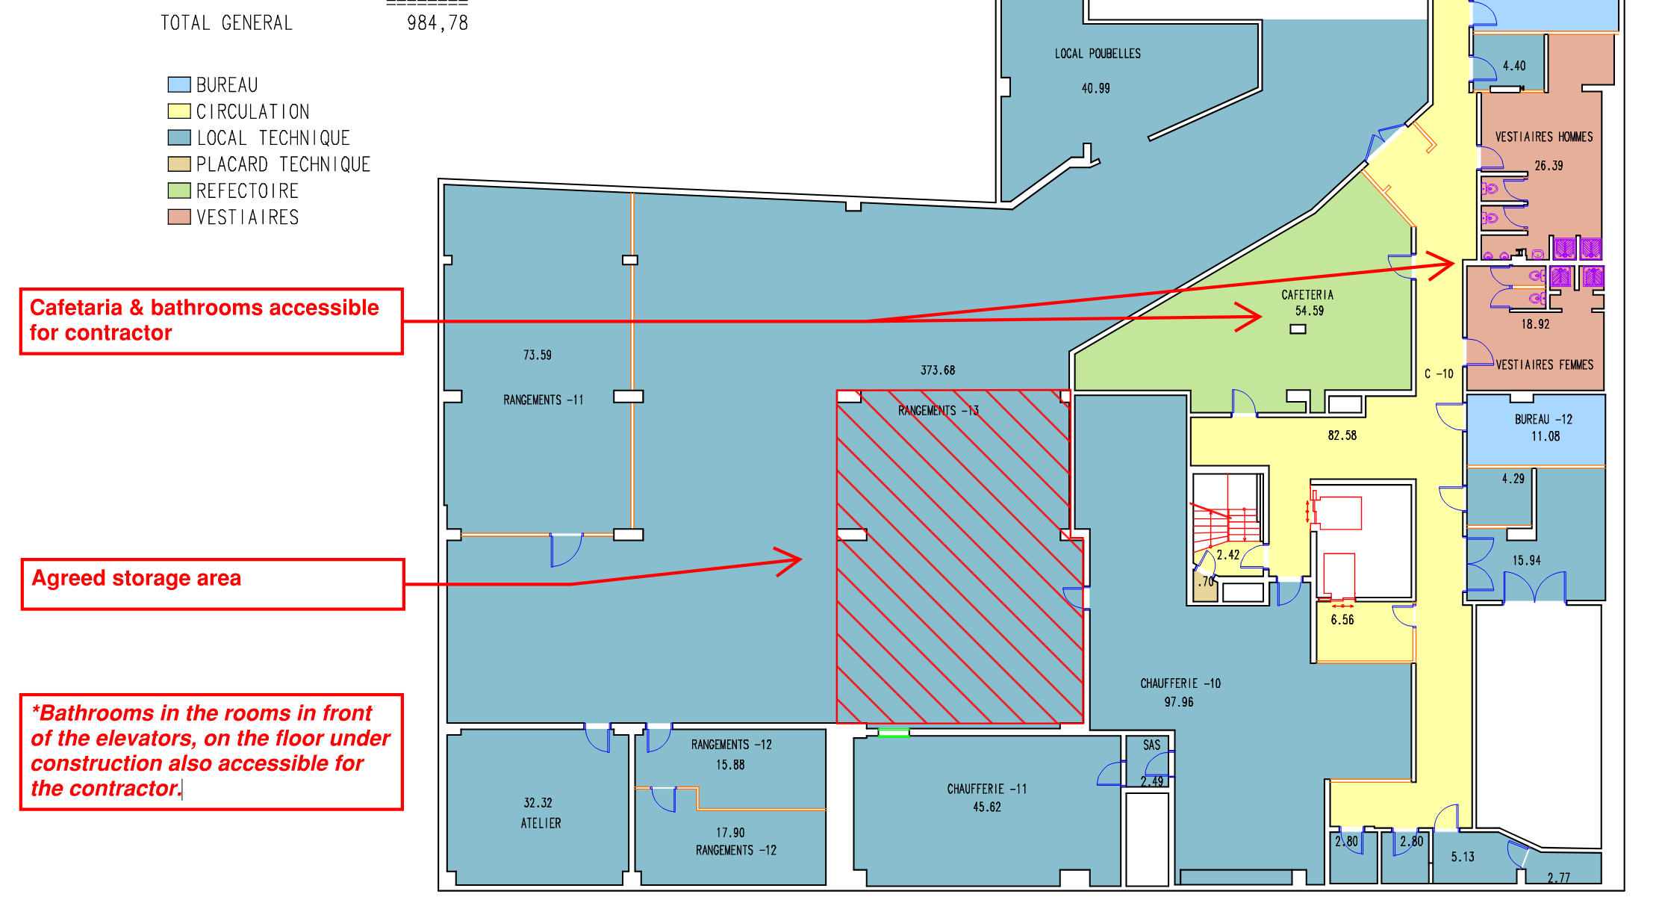

F. General remarks
This report will be subject to approval at the beginning of the next meeting; however, any corrections may be made upon receipt of it.

End of this report.

